/* MATERIAL TABLE */

insert into MATERIAL values (1, 'copper', NULL);

insert into MATERIAL values (2, 'vinyl', NULL);

insert into MATERIAL values (3, 'stone', NULL);

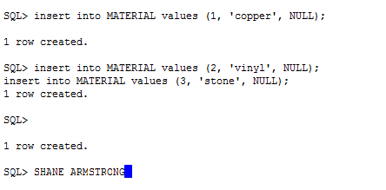

/* INSPECTION_ITEM_STATUS */

insert into INSPECTION_ITEM_STATUS values (1, 'Inspected' );

insert into INSPECTION_ITEM_STATUS values (2, 'Not Inspected' );

insert into INSPECTION_ITEM_STATUS values (3, 'Not Applicable');

insert into INSPECTION_ITEM_STATUS values (4, 'Failed Inspection');

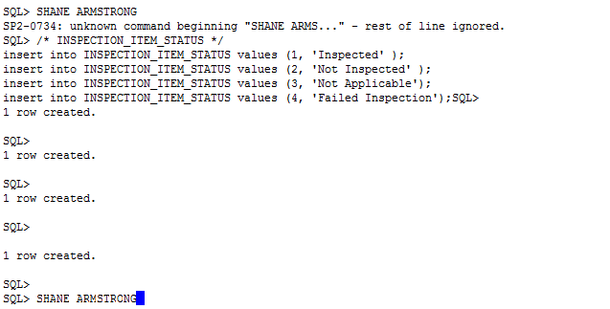

/* SUBSYSTEM*/

insert into SUBSYSTEM values (1, 'This is the kitchen subsystem', 1, 'The HVAC system passed inspection with no faults.' );

insert into SUBSYSTEM values (2, 'This is the Plumbing subsystem. The customer has an older house with some items not to code'

, 2, 'There will need to be some work performed to get the plumbing to code');

insert into SUBSYSTEM values (3, 'This is the exterior of the home.', 3, 'The exterior of the home will need some more work.' );

/* SUBSYSTEM_MATERIAL_JOIN */

insert into SUBSYSTEM_MATERIAL_JOIN values (1, 3,1 );

insert into SUBSYSTEM_MATERIAL_JOIN values (2, 1, 2 );

insert into SUBSYSTEM_MATERIAL_JOIN values (3, 2, 1 );

/* FLAG_STATUS */

insert into FLAG_STATUS values (1, 0);

insert into FLAG_STATUS values (2, 1);

/* INSPECTION_ITEM */

insert into INSPECTION_ITEM values (1, 4, 1, 1, NULL, 'The pipe dimensions are not to code' );

insert into INSPECTION_ITEM values (2, 1, 2, 0, NULL, 'There are no issues with the exterior of the home' );

/* ADDRESS_STATE */

insert into ADDRESS_STATE values (1, 'Virginia', 'VA');

insert into ADDRESS_STATE values (2, 'Maryland', 'MD' );

/* ADDRESS*/

insert into ADDRESS values (1, '3433 Jack Road', '', 'Jville', 1, 22209 );

insert into ADDRESS values ( 2, '3444 JoJo St.', 'Apt 3.', 'Woodford', 2, 34333);

/* INSPECTION_COMPANY */

insert into INSPECTION_COMPANY values (1, 1, 'MyCompany', '804-642-2256', NULL );

insert into INSPECTION_COMPANY values (2, 2, 'TheCompany', '757-509-2265', NULL);

/* INSPECTION_TYPE*/

insert into INSPECTION_TYPE values (1, 'Commericial' );

insert into INSPECTION_TYPE values (2, 'Residential' );

/* INSPECTION_TEMPLATE */ /*need to figure out the subsystem part*/

insert into INSPECTION_TEMPLATE values (1, 1 );

insert into INSPECTION_TEMPLATE values (2, 2);

/* INSPECTOR */

insert into INSPECTOR values (1, 'Jack Johnson', 1 );

insert into INSPECTOR values ( 2, 'John Johnson', 2);

/* CLIENT */

insert into CLIENT values ( 1, 1, '334-555-6666', 'me@email.com');

insert into CLIENT values ( 2, 2, '655-789-6654', 'you@email.com');

/* CONTRACT */

insert into CONTRACT values (1, 02-Jan-2012, 1, 1, 1, 'The inspector', 1 );

insert into CONTRACT values (2, 02-Jul-2014, 2, 2, 2, 'The inspector', 1 );

/* INSPECTION */

insert into INSPECTION values (1,1 );

insert into INSPECTION values (1,2 );

/* INSPECTION_REPORT */

insert into INSPECTION_REPORT values (1,1,1,1,1);

insert into INSPECTION_REPORT values ( 2,2,2,2,2);